Time Series Analysis of Housing in London Monthly Variables

Merve Ekiz Zehra Deniz Taş
Statistics Department Statistics Department
Middle East Technical University Middle East Technical University
Ankara, Turkey Ankara, Turkey
merve.ekiz@metu.edu.tr deniz.tas@metu.edu.tr

Abstract— This paper investigates the prediction of London's monthly housing price with different forecasting models such as ARIMA, ETS, TBATS, NN, and PROPHET. R-Studio version 4.0.3 is used for this study. Preprocessed data is applied before forecasts are made. The outlier analysis, data cleaning, and unit root checking are implemented. After processing noisy data, the forecast models are fitted, and their performances on both train and test data are compared with several comparison criteria.

Keywords—Forecast, housing price, nnetar, arima, seasonality

- INTRODUCTION
London is the eighth expensive city to buy a house in the world (The Top 10 Most Expensive Cities to Buy Property in the World!, 2019). In addition to this, housing prices fluctuated over time. In the light of these two facts, this study explores the average prices of houses sold in London over time.
The dataset is a monthly average housing price in the city of London, a local government and central business district, between the first of January 1995 and the first of January 2020.
Not only exploring the series but also the coming average housing price values are forecasted via ARIMA, ETS, TBATS, Neural Network, and Prophet models. Their performances were compared to some comparison criteria such as mean absolute percentage error (MAPE), mean absolute scaled error (MASE). During this study, R Studio 4.0.3 was used for all analyses.

- DATA DESCRIPTION AND PREPROCESSING
The data set is taken from https://kaggle.com. Also, the data from Kaggle has been extracted from London Datastore. It is released under UK Open Government License v2 and v3.
The dataset is removed from all the columns except average price and is subsetted by the area that is chosen the City of London.
The data set contains 13550 observations, which also means rows, recorded from January 1995 to January 2020 monthly. Data were collected on the first day of each month. This data indicates the seasonality, but the SARIMA approach fails.
To prepare the dataset, the four steps are applied:
The dataset is divided into train and test. The test data keeps the last 12 observations.
To achieve the stationary in variance, Box-Cox transformation is applied to the train data.
The Box-Cox transformed data is checked for anomaly detection by the GESD method, and after detection, the dataset is cleaned from the anomalies by a robust STL decomposition.
After these steps, the dataset was not stationary yet, so the differencing is applied to achieve it.
To identify the model, ACF and PACF plots are constructed. ARIMA(0,1,3) suggested.

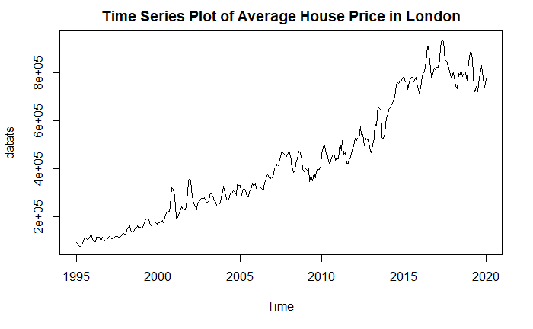
Graph 1: Time Series Plot of Data Set
It seems that the time series plot of the data is non-stationary. It is changed by time, and its mean term isn't constant. Also, it's seen that there is an increasing trend, which is probably a deterministic trend. Moreover, there may be seasonality. However, we need to look at some formal tests and other graphs to make an exact interpretation.

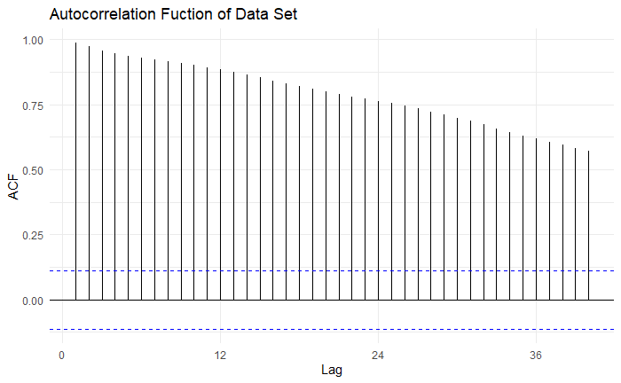Graph 2: ACF Plot of Data Set
Graph 2 shows a slow linear decay, which means that this plot supports the interpretation of non-stationarity. Hence, it can be said there is a non-stationarity process.
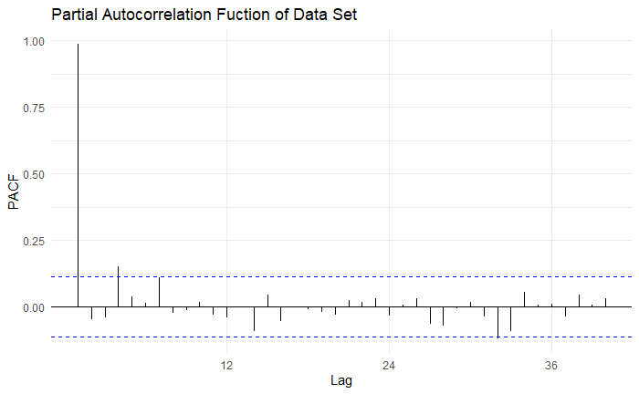Graph 3: PACF Plot of Data Set
It is seen that the PACF plot cuts after the fourth lag; however, since the non-stationarity process is decided for this data set, there is no need to interpret the PACF plot.
Before analyzing the data set, the data set is divided into two sets that are the train set and the test set. The test set includes the last 12 observations of the data set, and the remaining observations are kept as the train set. Before checking the anomalies in the train data, whether a transformation is needed or not should be checked since applied model-based statistical analysis generally requires some assumption to be conducted. Covariance-stationarity is one of these assumptions. Therefore, stabilizing the system's variance is needed for this assumption. When a lambda value for our train dataset is calculated to make the train set stationary in variance, it is seen that the lambda value is close to 0.5, so a power transformation is the most appropriate transformation method for this train set.
Then, the anomalies in the data are checked by using STL decomposition and shown that the series has anomalies. 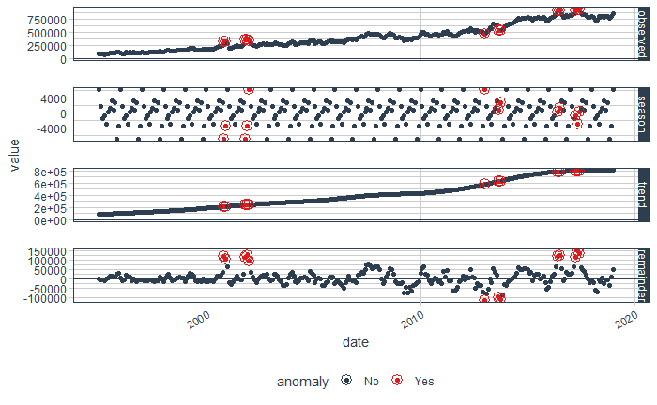
The anomalies in the train data are removed and replaced by interpolated values by the tsclean function. Also, graph 4 shows that the data set has seasonality and an increasing trend.
Another assumption to analyze a time series data set is stationarity in mean. To check stationarity in mean, the HEGY test and Canova - Hansen test are applied

HEGY Test for Train Data
Tpi_1 -0.3001 0.1
Tpi_2 -5.1069 0.01
Fpi_3:4 10.5353 0.01
Fpi_5:6 34.1148 0.01
Fpi_7:8 15.7082 0.01
Fpi_9:10 19.7510 0.01
Fpi_11:12 9.9033 0.01
Fpi_2:12 104.2562 NA
Fpi_1:12 95.8887 NA
Table 1. Hegy Test for Train Data
In this table 1, we will use the p-value of tpi_1 for the regular unit root and use the p-value of Fpi_11:12 for testing seasonal unit root. Since tpi_1 is greater than alpha, there is a regular unit root problem. However, Fpi_11:12 is less than alpha; there is not seasonality unit root problem. To solve the regular unit root problem, the differencing method is applied. There is no need to apply seasonal differencing. The process is constructed to eliminate the unit-roots to achieve the stationary, so the HEGY test should be applied to recheck it.
HEGY Test for Differenced Data
Tpi_1 -3.3967 0.01
Tpi_2 -4.7742 0.01
Fpi_3:4 8.2877 0.01
Fpi_5:6 8.8690 0.01
Fpi_7:8 13.8061 0.01
Fpi_9:10 15.9397 0.01
Fpi_11:12 14.5224 0.01
Fpi_2:12 18.6407 NA
Fpi_1:12 17.2424 NA
Table 2. HEGY Test for Differenced Data
The table 2 indicates no unit roots problem anymore because tpi_1 and Fpi_11:12 are less than alpha. Now, the stationary is provided.
The next step is applying another formal test Canova- Hensen. The null hypothesis indicates that the series is purely deterministic and stationary, and the alternative hypothesis indicates that there is a stochastic seasonality. After applying the Canova-Hensen test, since the p-value (0.2278) is greater alpha, we fail to reject the null hypothesis. Hence, it can be concluded that the seasonal pattern is purely deterministic and stationary.
To suggest the models, ACF and PACF plots are constructed.
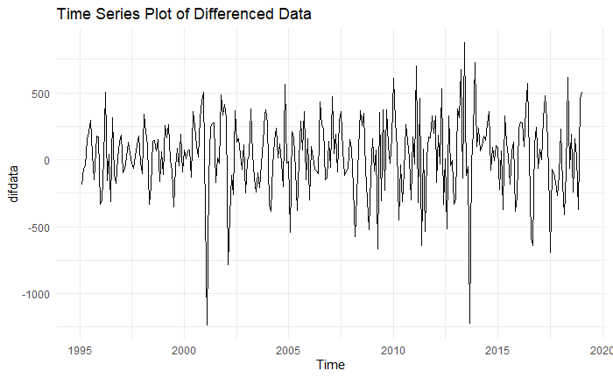 Graph 5: Time Series Plot of Differenced Data Set
It can be seen that the mean is around zero. Besides, there is no trend, and the series is stationary. However, there is volatility.

MODEL SUGGESTION
After obtaining a stationary series, a model can be suggested. o suggest the models ACF and PACF plots are constructed.
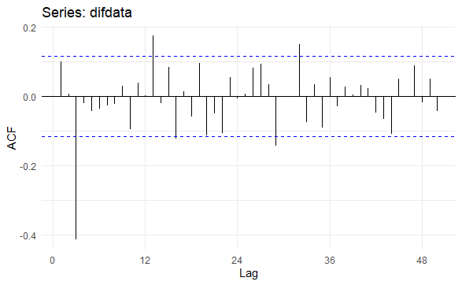 Graph 6: ACF Plot of Stationary Data Set
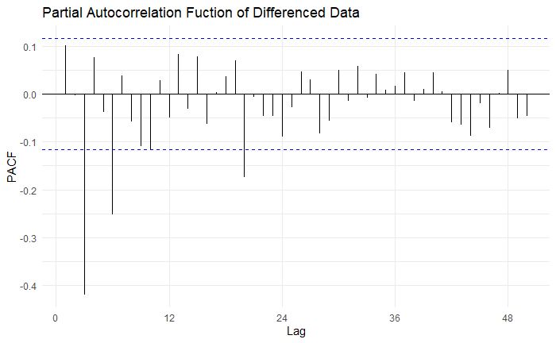 Graph 7: PACF Plot of Stationary Data Set
There is no slow decay in either the ACF and PACF plot, so the series is stationary. ACF of the process cuts off after lag three. By looking ACF plot, we identify the MA order of process. For the PACF plot, it can be said that it cuts off after lag three that gives the AR model's order. Also, it can be seen that there is seasonality. Therefore by looking at both ACF and PACF plot, ARIMA(0,1,3), ARIMA(3,1,3), SARIMA(3,1,3)(1,0,2) and SARIMA(0,1,3)(0,0,1) models can be suggested.

MODELLING AND DIAGNOSTIC CHECKING
After suggesting some models that may fit the series, their significance and performances should be compared according to some criteria to decide which model is the best-fitted one. When their significance is checked, it seems that SARIMA(3,1,3)(1,0,1)12, SARIMA(0,1,3)(0,0,1)12 and ARIMA(3,1,3) are insignificant because the ratio between these estimates and their standard errors are in an interval -2 to +2. Although the series has seasonality, because of some problems about the significance of the models and diagnostic, the series needs to be considered with the ARIMA model. When ARIMA(0,1,3) is considered, it is seen that ARIMA(0,1,3) is found as the significant model. When the AIC values of SARIMA models and ARIMA model are also compared, it is found that ARIMA(0,1,3) model has the lowest AIC value with respect to other models. Hence, ARIMA(0,1,3) can be selected as the most appropriate model for this series.
- ARIMA(0,1,3) Model
- Coefficents ma1 ma2 ma3
- 0.1688 0.0600 -0.4862
- s.e 0.0554 0.0544 0.0506
- Statistics 3.046931 1.102941 -9.608696
- sigma^2 estimated as 64758: log likelihood= -2002.9
- AIC= 4013.8 AICc=-4013.94 BIC=-4028.45
Table 3. Summary of ARIMA(0,1,3) Model
After identifying and deciding the time series model, the goodness of fit of the model and the validity of the assumptions should be checked. At this step, the model's residual is analyzed, which is similar to the traditional regression analysis. To check normality assumption, Q-Q plot as a visual tool and Shapiro - Wilk and Jarque - Bera test as the formal test are used. 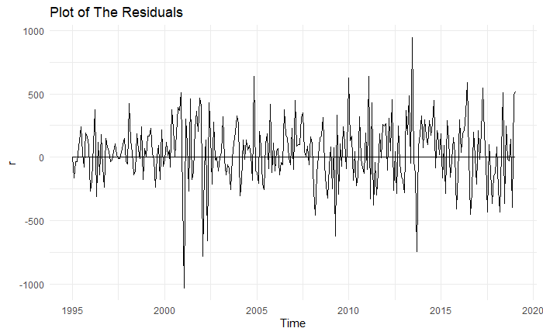
Graph 8: Plot of The Residuals
Before checking normality, it is better to visualize the residuals to see that their scattered point. The residuals plot shows that they are scattered around zero, and it can be interpreted as zero mean.
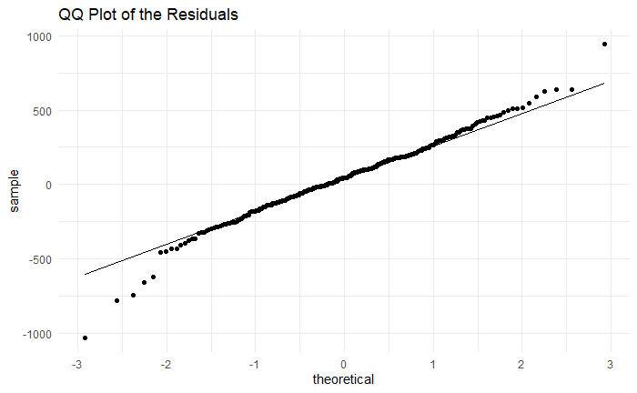 Graph 9: QQ plot of the standard residuals
Q-Q Plot shows that the residuals of the model seem to have light-tailed distribution (indicates S shape slightly). Besides, it has outliers. Hence, the residuals may not follow the normal distribution. To ensure whether residuals follow normal distribution or not, Shapiro-Wilk and Jarque- Bera test should be applied. Both test results say that the residuals don't follow the normal distribution (with Shapiro-Wilk p<0.05 & Jarque-Bera p<0.05).
Generally, non-normality can be solved by the transformation. Although power transformation is applied for this series, it doesn't resolve the normality problem of the residuals.
The next step is checking the serial autocorrelation. To detect the existence of serial autocorrelation, Box-Ljung Test and Box-Pierce Test as the formal test, and ACF plot as a visual way can be used.
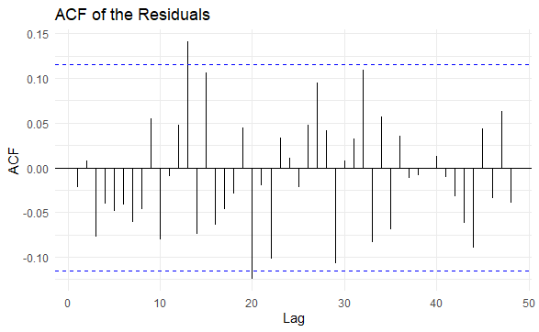 Graph 10: ACF Plot of the standard residuals
According to the ACF plot of the Standard Residuals, unfortunately, it is seen all spikes aren't in the White Noise. Therefore, it can be concluded that the residuals have serial autocorrelation. Typically, this problem can be solved by suggesting a different model. Although more than 10 SARIMA models are indicated for the series, none of them shows the satisfactory result. Thus, the most appropriate one seems ARIMA(0,1,3) model. The next step is checking the formal test. According to both Box-Ljung and Box-Pierce test, residuals of the ARIMA model are uncorrelated (p>0.05).
Heteroscedasticity of the residuals is the last assumption need to be checked. The residuals of the perfect forecasting model must have constant variance. As other assumptions, there are both visual and formal ways that ACF and PACF plot of squared residuals, ARCH Engle's test.
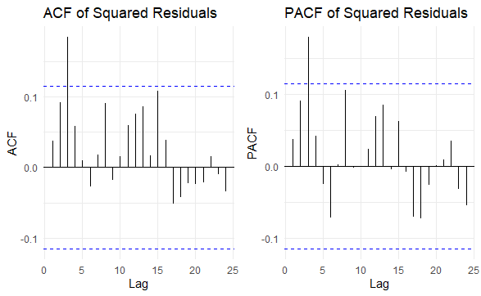 Graph 11: ACF and PACF of the Squared Residuals
Graph 11 shows that not all the squared residuals are in the White Noise Band. If the spikes aren't in the white noise band in both plots, then it can't be concluded that there is no heteroscedasticity problem. Moreover, ARCH Engle's test (p<alpha) says that there is an heteroscedasticity problem. Hence, it may be better to model this series by a (G)ARCH model.
After ARIMA and SARIMA models, the best exponential smoothing model is tried to find. Ets, ses, and holt function is used. Ets is used by two different parameters; ETS(M, A, A) and ETS(M, A, N). ETS(M, A, N) has the lowest AIC, and the ses model has the lowest RMSE value. ETS(M, A, N) model is given below.
ETS(M,A,N)
Smoothing parameters:
alpha = 0.9999

beta = 1.10⁻⁴

Initial states:
l = 81830.1054

b = 3520.5441

sigma: 0.0701
AIC AICc BIC
7468.864 7469.076 7487.16

Table 4: Summary of ETS Model
It is seen that we have an exponential smoothing model having multiplicative error and additive trend. After fitting the model, the ETS model's residuals are checked by the Shapiro-Wilk test and do not follow the normal distribution. (p<0.05)
After the exponential smoothing model, the TBATS model is fitted to the series. The model details are given below.
BATS(0.371, {0,3}, -, -)

Call: tbats(y = train)
Parameters
Lambda: 0.370689
Alpha: 1.083709
MA coefficients: 0.21318 0.200766 -0.707339
Sigma: 5.901219

AIC: 7312.751

Table 5: Summary of TBATS Model
According to the table 5, the AIC value of tbats is less than the AIC value of ETS(M, A, N).
After fitting the model, the TBATS model's residuals are checked by the Shapiro-Wilk test and seen that they do not follow the normal distribution. (p<0.05)
As a fourth model in the analysis, two different Neural Network models, NNAR(1,1,2)[12] and NNAR(2,1,2)[12], are fitted where past observations are considered input variables. Details of the models are given below.
model
## Series: train
## Model: NNAR(1,1,2)[12]
## Call: nnetar(y = train)
## Average of 20 networks, each of which is
## a 2-2-1 network with 9 weights
## options were - linear output units
## sigma^2 estimated as 620474164
Table 6: Summary of NNETAR Model of NNAR(1,1,2)[12]
model
## Series: train
## Model: NNAR(2,1,2)[12]
## Call: nnetar(y = train, p = 2, P = 1)
## Average of 20 networks, each of which is
## a 3-2-1 network with 11 weights
## options were - linear output units
## sigma^2 estimated as 597915925
Table 7: Summary of NNETAR Model of NNAR(2,1,2)[12]
Since residuals of the models' p-value are less than 0.05, there are nonnormal residuals according to the Shapiro-Wilk test. Sigma^2 values are compared, lower variance is chosen, so the better model is NNAR(2,1,2)[12]. The model is NNAR(2,1,2)[12]. It is a neural network with inputs Yt−1, Yt−2,..., Yt−12, and two neurons in the hidden layer.
Lastly, the prophet model is fitted. According to the Shapiro-Wilk test for the prophet model, since the residuals of the model p-value are less than 0.05, there are nonnormal residuals.
After fitting the models, the forecast values are obtained from each method using the forecast function and calculate their accuracy. The accuracy of the models is given below.
 | ME | RMSE | MAE | MAPE | MASE | ACF1
ARIMA | 43.02717 | 252.708 | 192.2878 | 2.9538 | 0.3362 | -0.021
ETS | -790.472 | 2549.1 | 18165.71 | 5.1990 | 0.3730 | 0.1207
HOLT | -792.831 | 25458.5 | 18163.18 | 5.1963 | 0.3730 | 0.1208
D.T.HOLT | 2108.248 | 25566.13 | 18277.99 | 5.1790 | 0.3754 | 0.1229
PROPHET | 9.439982 | 46269.62 | 34744.18 | 9.1097 | - | 0.8541
TBATS | 3492.653 | 20720.18 | 14884.27 | 4.0515 | 0.3057 | -0.038
NNETAR | -14.3367 | 24411.40 | 17787.36 | 4.8696 | 0.3653 | -0.021
Table 8: The train accuracy of models
 | ME | RMSE | MAE | MAPE | MASE | ACF1
ARIMA | -76421.7 | 86935.6 | 76421.71 | 10.188 | - | 0.3844
ETS | -108910 | 123245 | 113168.6 | 14.975 | 2.3243 | 0.4156
HOLT | -108909 | 123244 | 113167.6 | 14.975 | 2.3243 | 0.4156
D.T.HOLT | -86341.7 | 101205 | 91178.87 | 12.105 | 1.8726 | 0.3959
PROPHET | -153566 | 165618 | 153566.2 | 20.261 | - | 0.4475
TBATS | -85836.2 | 93742.6 | 85836.30 | 11.359 | 1.7629 | 0.3661
NNETAR | -53785.4 | 70340.8 | 59372.09 | 7.9326 | 1.2194 | 0.3927
Table 9: The forecasting performance of models
Train accuracy explains how much fitted values and observed values are close to each other. Test accuracy describes how much the forecasted values are close to each other.
The forecasting performance table indicates that the NNAR(2,1,2)[12] model outperforms the other methods compared to the test set to all measures. Also, it is seen that ARIMA(0,1,3) has the second-best forecasting performance when compared to other models. Lastly, the ETS and HOLT model has the lowest forecasting accuracy, as shown in the table above. On the other hand, the ARIMA model is the best for among within the train accuracy. Since this study's main purpose is to predict, NNAR(2,2) is chosen for the best model.
Following plots can also be helpful to observe the forecasting performance of the models.
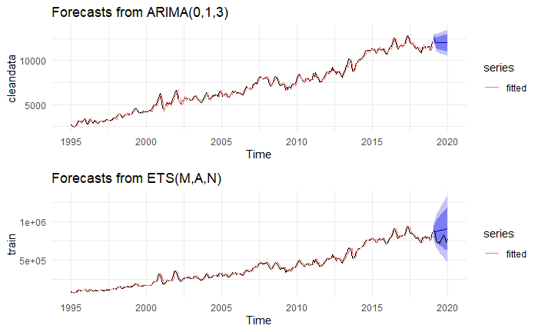
Graph 12. Forecast Plots of The Models

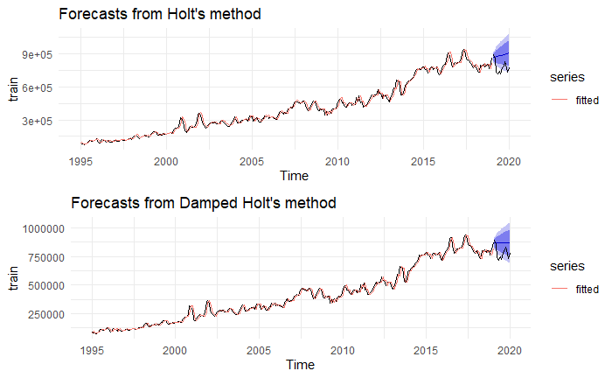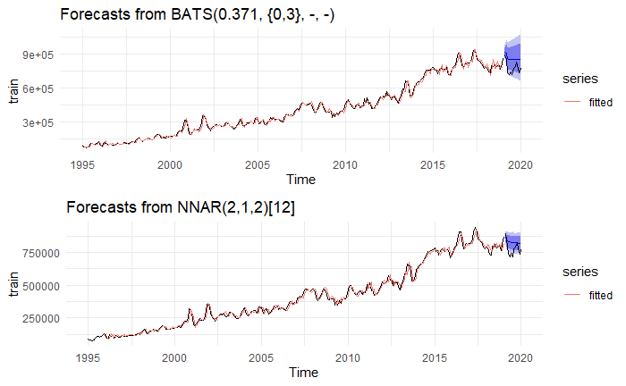
Graph 13. Forecast Plots of The Models
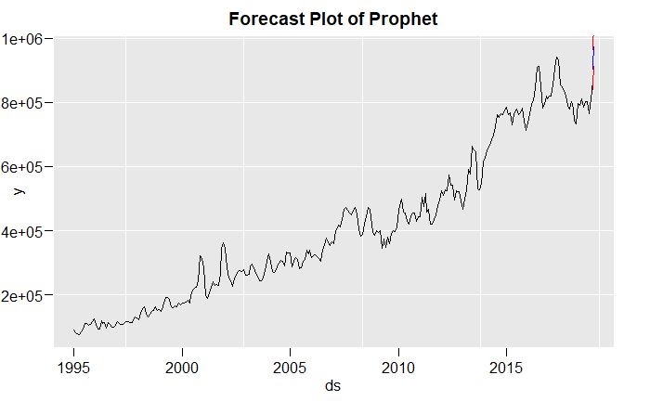
Graph 13. Forecast Plots of Prophet
The general aim is to find the narrowest prediction interval since how much narrow the interval is gives the future value to fall with the lowest error. According to the Graph 12, it is easily recognized that the NNAR(2,1,2)[12] has the narrowest prediction interval, also ETS(M,A,N) model seems to have the largest prediction interval. When table 9 is considered and compared with these plots, their accuracy value and prediction interval on the plots are perfectly matched. For example, according to the table 9, the lowest MAPE belongs to the NNAR(2,1,2)[12] model and the forecast plots of the NNAR(2,1,2)[12] also gives an evidence to select this model as the best model. It is better to keep in mind that although the nnetar model has the lowest MASE and the narrowest prediction interval, some of the test value isn’t inside the prediction interval. In addition, Damped Holt’s method and Holt’s method have the same problem. All in all, according to the test accuracy and the graphs, NNAR(2,1,2)[12] is the best model for this series to forecast the future value.

DISCUSSION AND CONCLUSION
In this study, the first step after data cleaning and dividing was the stationary check of the series. However, it is shown that this requirement was not met after looking at this seasonal time series, ACF&PACF plots, and the Hegy test results since there were a stochastic pattern and unit root problem in the series. In order to solve this problem, the differencing method was applied. After making the process stationary, the tentative models were suggested using specific methods such as ACF&PACF plots. The best model with fewer and significant parameters was chosen from these tentative models using AIC comparison. Even though the dataset has seasonality, the SARIMA model failed.
After fitting the best model, diagnostic checks are implemented on residuals. At this point, the non-normality of errors emerged, and some transformations such as ln and power are applied. However, these did not give any satisfactory solution. Also, there is a heteroscedasticity problem, so the ARCH/GARCH model is suggested. Although the errors are uncorrelated via the test, the ACF model of residuals has a significant spike. In addition to the best ARIMA models, eight different forecasting methods were considered, and the forecast from them are produced. At the end of comparing the forecasting method, NNAR(2,1,2)[12] has the best performance in predicting future values, and ARIMA has the best performance in modeling series compared to other models.
In conclusion, some problems occurred in the analysis process, and some of them came up with a solution while some are not. Despite these problems, the best model could be obtained. It has also been learned how to analyze time-series data sets, interpret ACF&PACF plots, results of formal tests, and find the forecast values of the series. When we look at the 25-year data, it is seen that the house prices are showing an increasing trend. With this study, we can see how much the house prices will increase in the future and when we consider buying a house in London, we can get a grip on the prices.

- References
The Top 10 Most Expensive Cities to Buy Property in the World! (2019, August). Cobalt Recruitment. https://www.cobaltrecruitment.co.uk/blog/2019/08/the-top-10-most-expensive-cities-to-buy-property-in-the-world

